**Project Design Phase-II**

**Technology Stack (Architecture & Stack)**

|  |  |
| --- | --- |
| Date | 16 November 2022 |
| Team ID | PNT2022TMID51374 |
| Project Name | A Gesture-based Tool for Sterile Browsing of Radiology Images |
| Maximum Marks | 4 Marks |

**Technical Architecture:**

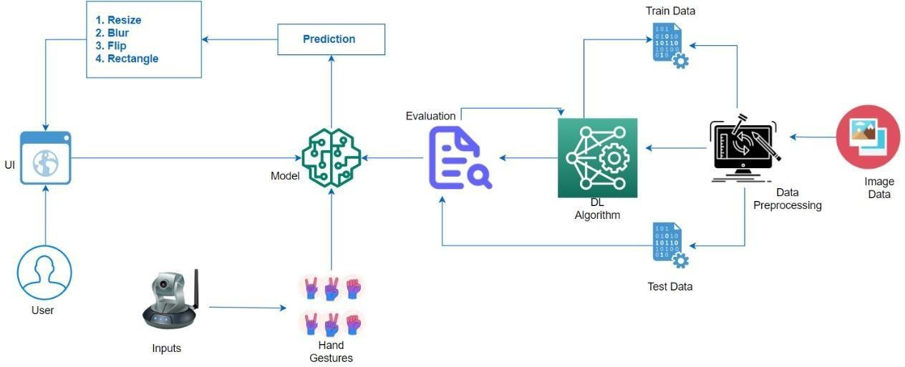

**Table-1 : Components & Technologies:**

|  |  |  |  |
| --- | --- | --- | --- |
| **S.No** | **Component** | **Description** | **Technology** |
| 1. | User Interface | UI ( Web ) | HTML, CSS, JavaScript. |
| 2. | Application Logic-1 Image Pre- processing | Input image is pre-processed with the help of library files. | Python, TensorFlow |
| 3. | Application Logic-2 Building Model | Building CNN model to recognize the gesture. | Python, Keras |
| 4. | Application Logic-3 Creation of app | App is built to obtain gesture as input and to provide as output. | HTML, CSS, JavaScript |
| 5. | Dataset | Hand gesture data set. | From IBM |
| 6. | Cloud Database | User input image is stored in cloud. | IBM Cloud |
| 7. | File Storage | File storage contains dataset and source code. | Device or Drive |
| 8. | Machine Learning Model | CNN Model was used to recognize the pre- processed image by image capturing or by video segmenting. | CNN Model by Python, Keras |

**Table-2: Application Characteristics:**

|  |  |  |  |
| --- | --- | --- | --- |
| **S.No** | **Characteristics** | **Description** | **Technology** |
| 1. | Open-Source Frameworks | Application development, data pre-processing. | Visual studio code, Anaconda navigator, TensorFlow |
| 2. | Security Implementations | It identifies the gesture only when the hand is in front of the camera. | OpenCV |
| 3. | Scalable Architecture | It can be used in any environment and is able to identify the gesture | OpenCV |
| 4. | Availability | It is used to reduce the possibility of spreading infections | AI |
| 5. | Performance | Rapid response to the gesture. | CNN |